**RIS SIU Requirements**

**1.1**

**Prepared By: Art Schwartz**

**Date: 7/28/2016**

Document Control 3

Resources 3

Project Distribution List 3

Document Version Control 3

1. Introduction 4

1.1 Purpose 4

1.2 Project Scope 4

1.3 Terminology Standards 4

1.3.1 Acronyms 4

1.3.2 Glossary 4

1.4 Document References 4

*2.* Diagram 5

3. Requirements 6

3.1 Functional Requirements 6

3.2 Non-Functional Requirements 6

3.3 Messaging Protocols 7

3.3.1 Inbound to the BayCare Cloverleaf 7

3.3.2 Outbound to the BayCare Cloverleaf 7

3.3.3 Inbound to the Vendor 7

3.3.4 Outbound to the Vendor 7

3.3.5 Inbound to the BayCare Cerner 7

3.3.6 Outbound to the RIS 7

4. HL7 Messaging 8

4.1 Messaging Format 8

4.1.1 Segments 8

4.1*.*2 Messaging Event Types 9

4.1*.*3 Cloverleaf Configuration Files 9

4.1.4 Cloverleaf Site Location 9

4.2 Data Transformation Requirements 9

4.3 Sample Message 13

5. Testing 13

5.1. Unit Testing Scenarios 13

5.2 Integrated Testing Scenarios 13

5.3 Testing Approvals 14

5.4 Piloting 14

5.5 Approvals 14

6. Deployment / Implementation Model 14

Appendix A: Risks and Concerns 16

Appendix B: Issues List 17

# **Document Control**

## Resources

|  |  |  |
| --- | --- | --- |
| **Name** | **Role** | **Email** |
| Art Schwartz | BayCare Cloverleaf Developer | [art.schwartz@baycare.org](mailto:art.schwartz@baycare.org) |
|  |  |  |
|  |  |  |
|  |  |  |
|  |  |  |
|  |  |  |
|  |  |  |
|  |  |  |

## Project Distribution List

## Document Version Control

|  |  |  |  |
| --- | --- | --- | --- |
| **Version** | **Date** | **Modifier** | **Description** |
| 1.0 | 6/16/2016 | Art Schwartz | Originally Created |
| 1.1 | 12/14/17 | Tiffany Bohall | Updated facility filtering |
|  |  |  |  |
|  |  |  |  |

# 1. Introduction

## 1.1 Purpose

This document is intended describe the integration between the Soarian HIS and RIS for SIU. It will cover the mapping, protocol configuration, and special logic required to successfully integrating RIS with the Soarian HIS.

## 1.2 Project Scope

The project is an effort to optimize of a standard interface for SIU across all facilities in the BayCare Health System.

## 1.3 Terminology Standards

### 1.3.1 Acronyms

Click here to enter text.

### 1.3.2 Glossary

Click here to enter text.

## 1.4 Document References

Click here to enter text.

# *2.* Diagram

Provide a solution diagram that depicts the integration of components specified in this IDBB. This diagram must include the data flow for the interfaces (source and target).



# 3. Requirements

## 3.1 Functional Requirements

|  |  |  |
| --- | --- | --- |
| **Cloverleaf** |  |  |
| **Number** | **Requirement Name** | **Requirement Description** |
| FR.2016.1.0 | Message Filtering | Kill any SIU with DCJ5 (MPMDC) in MSH.3  Kill any S14 with these schedule types (SCH-5 =) {SCHEDINTFCENCASSOC05 SCHEDREVISEMEDNEC SCHEDAPPTCONF SCHEDAPPTUNCONF SCHEDAPPTATT SCHEDAPPTUNDOATT SCHEDAPPTACTUALSTART APPTUNDOACTUALSTART SCHEDAPPTNOSHOW SCHEDAPPTUNDONOSHOW SCHEDAPPTCOMPLETE SCHEDINTFCAPPTATEND SCHEDAPPTUNDOCOMPLETE SCHEDAPPTRESET SCHEDINTFCAPPTNOSHOW SCHEDINTFCAPPTUNDONOSHOW  Kill any message with a ZAD-2 other than BD CD CT DX EC IR MR NEURO NM PET PN SP US WM XR  Kill any message with a AIS-2 that contains JHINPATIENT  Kill any message where AIL-3 is LBHMDRW |
|  |  |  |
|  | Echo exam valid | If Echo (ZAD-2) equal EC kill any not in the EC_valid_exam Table |
|  |  |  |
|  |  |  |

## 3.2 Non-Functional Requirements

Provide concise detail for the below non-functional requirements. The below requirements must be evaluated for every project.

|  |  |  |
| --- | --- | --- |
| **Cloverleaf** |  |  |
| **Number** | **Requirement Name** | **Requirement Description** |
| NFR.20XX.1.0 | Click here to enter text. | Click here to enter text. |

## 3.3 Messaging Protocols

Below are listed the details for the messaging protocols that will be leveraged for this integration.

### 3.3.1 Inbound to the BayCare Cloverleaf

* Click here to enter text.

### 3.3.2 Outbound to the BayCare Cloverleaf

* Click here to enter text.

### 3.3.3 Inbound to the Vendor

* Click here to enter text.

### 3.3.4 Outbound to the Vendor

* Click here to enter text.

### 3.3.5 Inbound to the BayCare Cerner

Test

Port Number: 20007

IP Address: 10.5.250.203.

Prod

Port Number: 20007

IP Address: 10.5.250.201.

### 3.3.6 Outbound to the RIS

Test

Port Number: 7500

IP Address: 10.4.3.36

Prod

Port Number: 11200.

IP Address: 10.4.3.167

# 4. HL7 Messaging

## 4.1 Messaging Format

### 4.1.1 Segments

The segments utilized for this interface are:

MSH

SCH

PID

[PD1]

[PV1]

[RGS]

[{AIS}]

[{AIG}]

[ZOR]

[ZAD]

*Message Construction Notes:*

*[Square Brackets] – Optional*

*{Curly Brackets} – Repeatable*

*MSH – Message Header*

*SCH – Scheduling activity Information segment*

*PID – Patient ID segment*

*PD1 – Patient additional demographic*

*PV1 – Patient Visit segment*

*RGS – Resource Group*

*AIS – Appointment Information Segment*

*AIG – Appointment Information general Resource Segment*

*ZOR – ZOR Segment*

*ZAD – ZAD Segment*

*[{ – Start of optional, repeatable group*

*}] – End of optional, repeatable group*

### 4.1*.*2 Messaging Event Types

Below are the messages types necessary for this integration

|  |  |
| --- | --- |
| **Event Type** | **Description** |
| S12 | Notification of new appointment |
| S13 | Notification of appointment reschedule |
| S14 | Notification of appointment modification |
| S15 | Notification of appointment cancelation |

### 4.1*.*3 Cloverleaf Configuration Files

Translate – soars_idx_siu.xlt

Variant – HL7 2.6 Soarian ADT

### 4.1.4 Cloverleaf Site Location

Test – imaging

Production - imaging

## 4.2 Data Transformation Requirements

| **Field Description** | **HL7 Field Loc.** | **Required Y/N** | **Data Type** | **Length** | **Notes** |
| --- | --- | --- | --- | --- | --- |
| MSH | * | Y | N/A | N/A | Entire MSH is sent to RIS |
| Sending Application | MSH:3.0 |  |  |  | Hardcode SOARIAN |
| Sending Facility | MSH:4.0 | Y |  |  | From MSH-4 via Table soars_idx_facility_codes  If result Value = BOI  Pass PV2-23 thru soars_boi_org_codes table  If PV2-23 equal null use AIL-3  IF AIL-3 equal MOI  Hardcode BCMOI |
| Receiving Application | MSH:5.0 | Y |  |  | Hardcode SOARIAN to MSH-5.1  Hardcode SCHEDULING to MSH-5.2  If result of Pv1-4 table is Value = BOI  Pass PV2-23 thru soars_boi_org_codes table  If PV2-23 equal null use AIL-3  IF AIL-3 equal MOI  Hardcode BCMOI |
| Sending Application | MSH:6.0 |  |  |  | From MSH-4 via Table soars_idx_facility_codes  If result Value = BOI  Pass PV2-23 thru soars_boi_org_codes table  If PV2-23 equal null use AIL-3  IF AIL-3 equal MOI  Hardcode BCMOI |
| Placer appointment ID | SCH-1 |  |  |  | Pass 10th char to medness variable. If =Y copy to ZSI-2 |
| Filler appointment ID | SCH-2 | Y |  |  | Copy to SCH-1 |
| Event Reason | SCH-6 |  |  |  | Copy |
| Appointment Reason | SCH-7 |  |  |  | Copy |
| Appointment Duration | SCH-9 |  |  |  | Copy |
| Appointment Duration Units | SCH-10 |  |  |  | Copy |
| Appointment Timing quantity | SCH-11 |  |  |  | Copy 4th sub-field |
| Entered by Person | SCH-20 |  |  |  | Copy |
| Set ID PID | PID-1 |  |  |  | Copy |
| Patient ID | PID-2 |  |  |  | Copy CPI from PID-3 (if PID-3.3 =900000 |
| Patient Identifier list | PID-3 |  |  |  | Copy CPI to PID-2  Copy SS# to PID-19 |
| Patient Name | PID-5 |  |  |  | Copy |
| DOB | PID-7 |  |  |  | Copy |
| Gender | PID-8 |  |  |  | Copy |
| Race | PID-10 |  |  |  | Copy |
| Patient Address | PID-11 |  |  |  | Copy |
| Phone Number Home | PID-13 |  |  |  | Copy Home to PID-13.1  Copy Cell to PID-13.2 |
| Phone Number Work | PID-14 |  |  |  | Copy |
| Primary Language | PID-15 |  |  |  | Copy |
| Patient Account Number | PID-18 |  |  |  | Copy |
| Set ID | PV1-1 |  |  |  | Copy |
| Patient Class | PV1-2 |  |  |  | Copy, If PV1-18 = ER copy E to PV1-2 |
| Patient location | PV1-3 |  |  |  | Copy first 3 sub fields, send 4th sub filed thru table soarf_facility_codes |
| Prior Patient location | PV1-6 |  |  |  | Copy first 3 sub fields, send 4th sub filed thru table soarf_facility_codes |
| Attending doctor | PV1-7 |  |  |  | Concat MS and doc number to first subfield.  use SCH-12 as source |
| Referring Doctor | PV1-8 |  |  |  | Concat MS and doc number from PV1-7 to first subfield  use SCH-12 as source |
| Hospital Service | PV1-10 |  |  |  | Copy |
| Fin Class | PV1-20 |  |  |  | Copy |
| Set ID | DG1-1 |  |  |  | Copy |
| Diagnosis date | DG1-3 |  |  |  | Copy |
| Set ID | RGS-1 |  |  |  | Copy |
| Segment Action Code | RGS-2 |  |  |  | Copy |
| Resource Group ID | RGS-3 |  |  |  | Copy |
|  | AIS Segment |  |  |  | Pathcopy segment |
| Universal Identifier | AIS-3 |  |  |  | If the 2nd sub field of NTE-3 = RT,LT or 50 concat AIS-3, “&” and NTE-3.2 |
| Universal Identifier | AIS-3 |  |  |  | If NTE-3,0 starts and NTE-3.2 starts with Corp and NTE3.1 = Y add &PROMO to end of AIS-3 |
|  | NTE Segment(s) |  |  |  | Pathcopy segment |
| Comment | NTE-3 |  |  |  | If NTE-4 = REFAUTH then Blank out 2nd and 3rd sub-fields  Concat first sub-filed, -, and 2nd subfield to 1st subfield |
| Resource ID | AIG-3 |  |  |  | Copy and remove 2 leading chars on resource ID |
| Resource ID | AIG-3 |  |  |  | If AIG-3 = JHANES1 concat & JHANES1 to AIS-3 |
|  | ZSI-7 |  |  |  | Null out |
|  | ZSI-10 |  |  |  | If NTE-3.0 = STAT copy NTE-3.2 |
|  | ZAD-2 |  |  |  |  |
|  |  |  |  |  | If ZAD-2 equal PET hardcode Y |

## 4.3 Sample Message

# **5. Testing**

## 5.1. Unit Testing Scenarios

|  |  |
| --- | --- |
| **Scenario** | **Expected Result** |
|  |  |
|  |  |
|  |  |
|  |  |
|  |  |
|  |  |
|  |  |
|  |  |
|  |  |

## 5.2 Integrated Testing Scenarios

|  |  |
| --- | --- |
| **Scenario** | **Expected Result** |
|  |  |
|  |  |
|  |  |
|  |  |
|  |  |
|  |  |

## 5.3 Testing Approvals

|  |  |  |  |
| --- | --- | --- | --- |
| **Testing Phase** | **Date** | **Department** | **Team Member** |
| PH1.UNIT |  |  |  |
| PH1.INTEGRATED |  |  |  |

### 

## 5.4 Piloting

The Teletracking Optimization project will be first piloted at WHH and WHW hospitals

## 5.5 Approvals

|  |  |  |  |
| --- | --- | --- | --- |
| **Testing Phase** | **Date** | **Department** | **Team Member** |
| PH1.0 |  |  |  |
|  |  |  |  |
|  |  |  |  |

# 6. Deployment / Implementation Model

Provide the detail as to how to deploy the solution defined in the IDBB from both the BAYCARE and vendor perspective.

Soarf_facilty_codes table

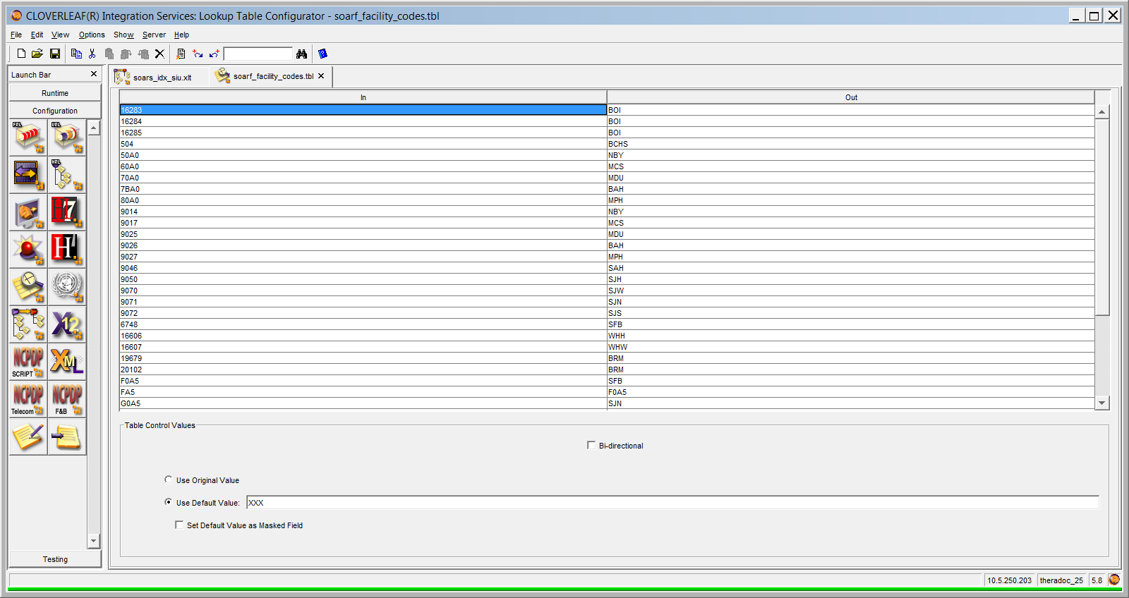

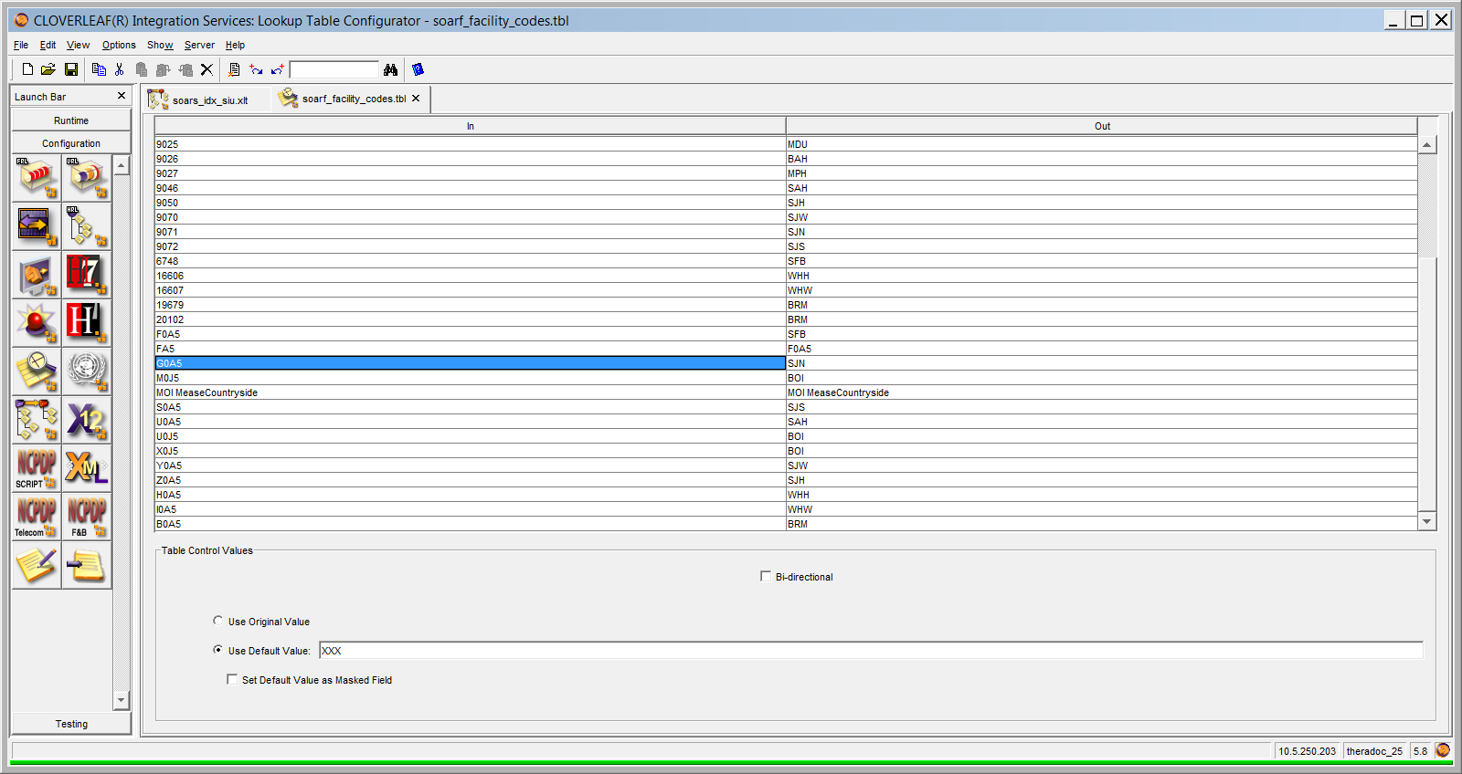

# Appendix A: Risks and Concerns

|  |  |  |  |  |  |  |  |  |
| --- | --- | --- | --- | --- | --- | --- | --- | --- |
| **Project Name** |  |  | | |  |  |  |  |
| **Number** | **Risk / Concern** | **Comment** | **Mitigation** | | |  |  |  |
| RC.2013.1.0 |  |  | |  | |  |  |  |

# Appendix B: Issues List

This is a dynamic list of the open issues related to the IDBB that remain to be solved, including but not limited to TBDs, pending decisions, information needed, conflict awaiting resolution, and the like.

|  |  |  |  |  |  |  |  |  |
| --- | --- | --- | --- | --- | --- | --- | --- | --- |
| **Project Name** |  |  | | |  |  |  |  |
| **Number** | **Issue** | **Comment** | **Fix** | | |  |  |  |
| I.2013.1.0 |  |  | |  | |  |  |  |

EC_valid_exam

|  |
| --- |
|  |
| EECHO |
|  |
| EECHOBOI |
|  |
| EECHOSTR |
|  |
| EECHOSTRD |
|  |
| ETEE |
|  |
| EECHOGPED |
|  |
| ETEEP |
|  |
| EECHOCF |
|  |
| EECHO3D |
|  |
| EECHOPERIP |
|  |
| EECHOCNGP |
|  |
| ECHOCGLTDP |
|  |
| EECHOFUP |
|  |
| EECHOCP |
|  |
| ETEECONGP |
|  |
| EECHOSTRP |
|  |
| ETEECONGIR |
|  |
| EHMHKUP |
|  |
| ETEECONGPR |
|  |
|  |
| ETEEINOP |
|  |
| ETEEIR |
|  |
| EECHOSTRT |
|  |
| EEKG |
|  |
| EEKGPED |
|  |
| ESTRESS |
|  |
| ESTRESSD |
|  |
| ESTRESSP |
|  |
| ESTRTREAD |
|  |
| EHM24HR |

* End of document